THE PLACE MAT STRAT

Variations of what it can look like:
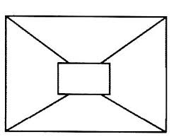
Any type of big idea, question, vocab, math problem, or topic could be written about discussed. The placemat is placed in the middle of 4 students.

• Ask students to first think about the concept or content on their table – no talking. Then ask the students to write their ideas, answers, etc. in the area of the place mat closest to them. Students should leave the middle section of the place mat empty.

• Now ask participants to share their ideas with their own group – going around the table. After everyone has shared, have the group summarize the groups’ consensus of ideas and write it in the middle section of the place mat.

• You can have each group identify one member to present their place mat back to the entire class.
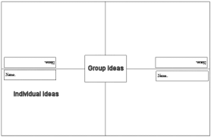

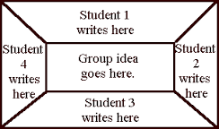

Benefits of the Place Mat
•When students have appropriate “think time”, the quality of their responses improves.
•Students are actively engaged in the thinking; independent thinking is encouraged.
•More critical thinking is retained from a lesson when students have an opportunity to discuss and reflect on the topic.
•It is important for students to learn how to build on the ideas of others, combine common thoughts, and write them down as a group.

