SPEED DATING PROTOCOL

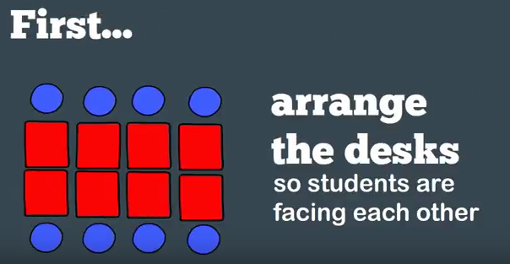
- Give students various questions (about 5-10) to ponder and write about on a particular topic. (This can be done as a journaling or warm up exercise or can be given as homework).
http://www.mudandinkteaching.com
- Once students have been given ample time to write their own answers to each question, you will start the speed-dating component.

- Students can take their paper with their answers on it around with them; however, they should not read their responses.
- Sit students with a partner, facing each other across a desk. The students as a whole should be in one or two straight lines so that they can easily move from one “date” to the next. Assign one side A and the other B.
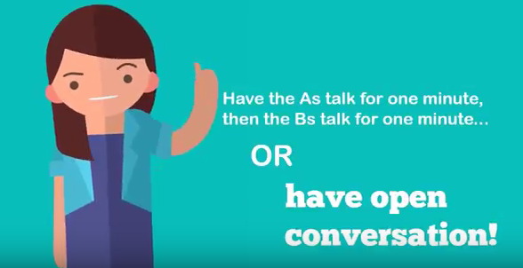
- When you tell them to go, the students will discuss only the first question with their first partner. Give them about one minute to do so. (Thus, the speediness).
http://www.mudandinkteaching.com

- After a minute has passed, have one line of students stay put (A) and have the other line (B) move one seat down to a new partner.
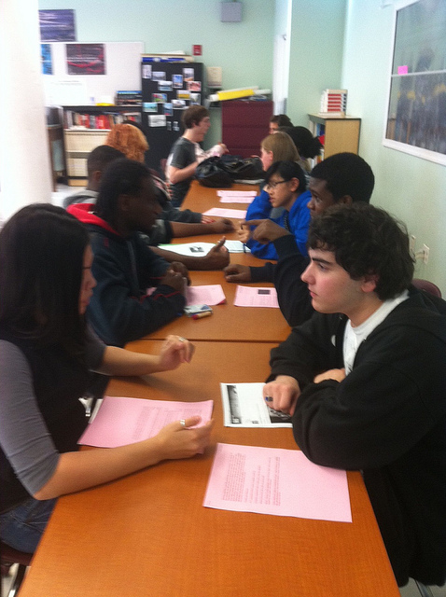
- With their new partner, they will have one minute to discuss #2 and so on down until all questions have been discussed for a minute, each with a different person.
- After all questions have been discussed, debrief as a class. Discuss each question and what new insights were offered on their dates.
TECH TIP: You could have students post their aha moment or most insightful idea in a Padlet. Then you would have a record of student responses to each question.
You could add some fun sentence frames. From my date, _________, I learned….
My most provocative date was _________, as they challenged me to think differently about… (This word can lead to a discussion in denotation and connotation.)

