Deepening Comprehension through
Second-draft reading

RESPONSIBILITY PIE CHARTS

Another way to help prompt deeper thinking is to ask students to consider which characters or people are most responsible for the book’s outcome.

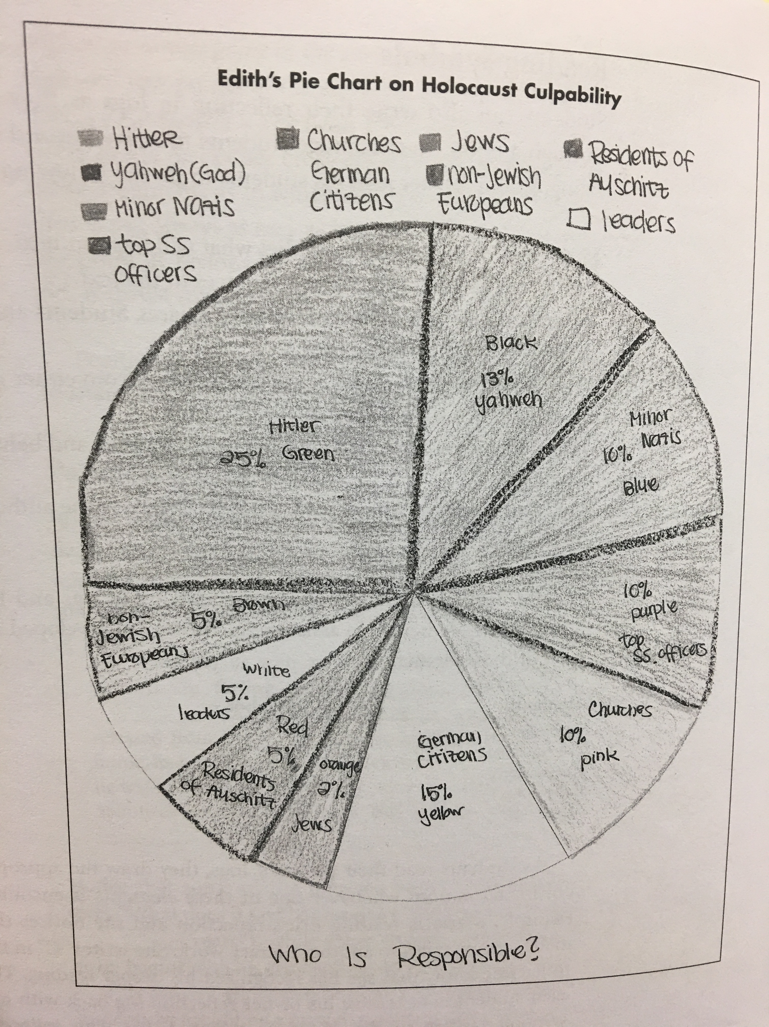
At the end of the unit on Night, a nonfictional account of the Holocaust, students brainstormed the various people and groups who played a role in the genocide of World War II.

While it’s easy to blame Hitler, students need to realize that he needed a lot of help to murder millions of people. As a class, brainstorm all the people and groups who played a role in the Holocaust.

Responsibility pie charts can work with any book that carries a strong ending: Who shared responsibility for the deaths of Romeo & Juliet? For the fall of Hamlet? For the demise of Piggy? Who was most to blame? Who was indirectly responsible? Having students consider these questions prompts them to revisit the text and to consider the consequences of the actions (or inaction) of others.

These activities demonstrate to students the value of revisiting text. Deeper meaning emerges when difficult text is reread, and these strategies, through repeated modeling, help to break students from their “I read it one time and I don’t get it” mentality.

