Reading Strategies
CCSS.ELA-Literacy.CCRA.R.1. Read closely to determine what the text says explicitly and to make logical references from it; cite specific evidence when writing or speaking to support conclusions drawn from the text.

17-Word Summaries

You, or your students, can pick ANY number between 10-20. Ask them to write a summary that contains EXACTLY that many words.
Benefits:
  ☑ It not only teaches them to summarize but also teaches them to pay close attention to sentence structure and word choice.
☑ Quick, effective formative assessment: you can read the response very quickly to get an instant sense of who understands the text and who does not.

Examples from Chapter 1 of Lord of the Flies
- Ralph and Piggy are stranded, but with the help of a conch shell, they discover more kids.
- Because of a plane crash, a group of kids are stranded on an island with no adults.
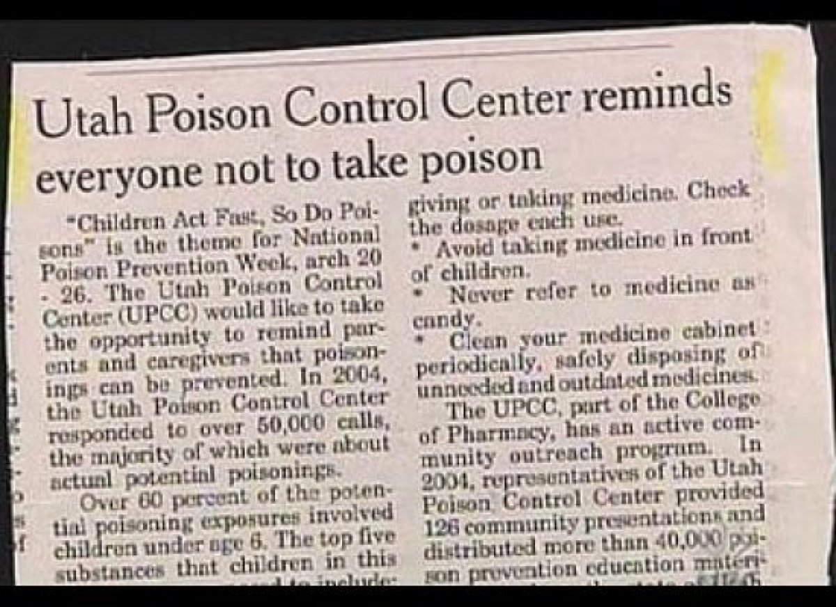
Write a Headline or Guess the Headline

To help students refine their summary skills, you can have them create headlines for actual articles (Newsela)
Here are some actual headlines that overstate the obvious (and are unintentionally funny):
- “Most Earthquake Damage is Done by Shaking”
- “City Council Runs Out of Time to Discuss Shorter Meetings”
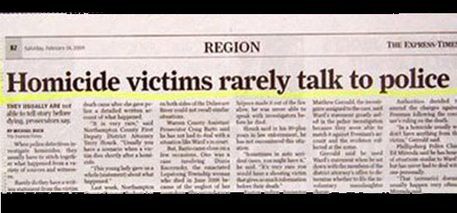
After a brief description of what makes an effective headline, you can remove the headline from articles and ask them to supply their own.

Source: Huffington Post 2012

Guess the headline: _____________________________________________

MIAMI, Fla. — The National Basketball Association (NBA) and its players union urged teams this week to come up with ideas to create social change in cities across the country. This comes after more than a year of protests over the death of African-American men at the hands of police.

Detroit Pistons coach Stan Van Gundy said he supports whatever his team decides to do. He's urging them to make an impact.

"No one can be happy with what's going on right now," Van Gundy said Friday, as NBA teams began gathering to start training camp. Van Gundy said he agrees with Golden State coach Steve Kerr that no one can say the recent shootings are not a problem. "I mean, we're shooting unarmed people — and you've got to think largely, they are seen as threats largely because of their race. I mean, it's hard to fathom," Van Gundy said.

Window Quotes (Pull Quote)
Often in longer magazine articles the editor will choose a key line or quotation and feature it in a window quote, a box placed in the article so that the text of the article wraps around it.
The purpose of the window quote is to lure the reader into the piece by highlighting something interesting from the article. This quote also captures the big idea of the piece.
Benefits:
☑ Provides practice at selecting the most important evidence from the text.
☑ Teachers can ask students to justify their selections. Students can evaluate which window quotes are the most effective at supporting a specific claim.
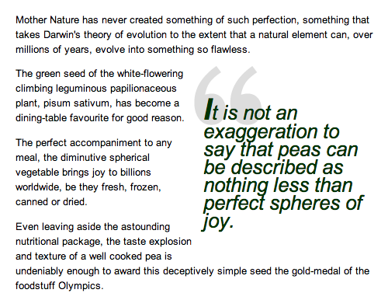
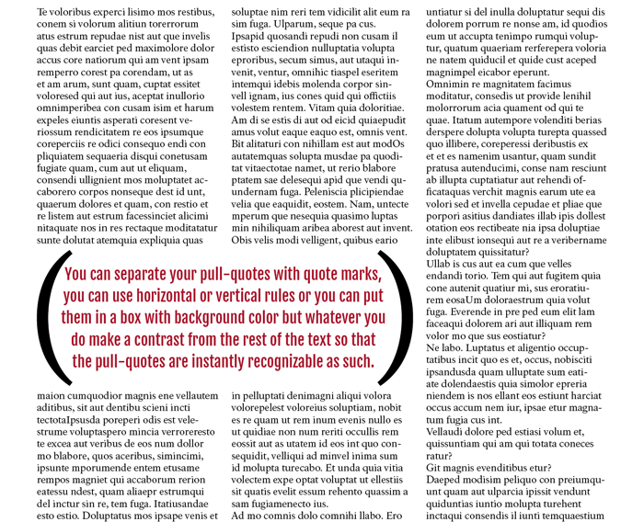
☑ Students can write on a note card, put a box within the text, Cornell Notes, etc.
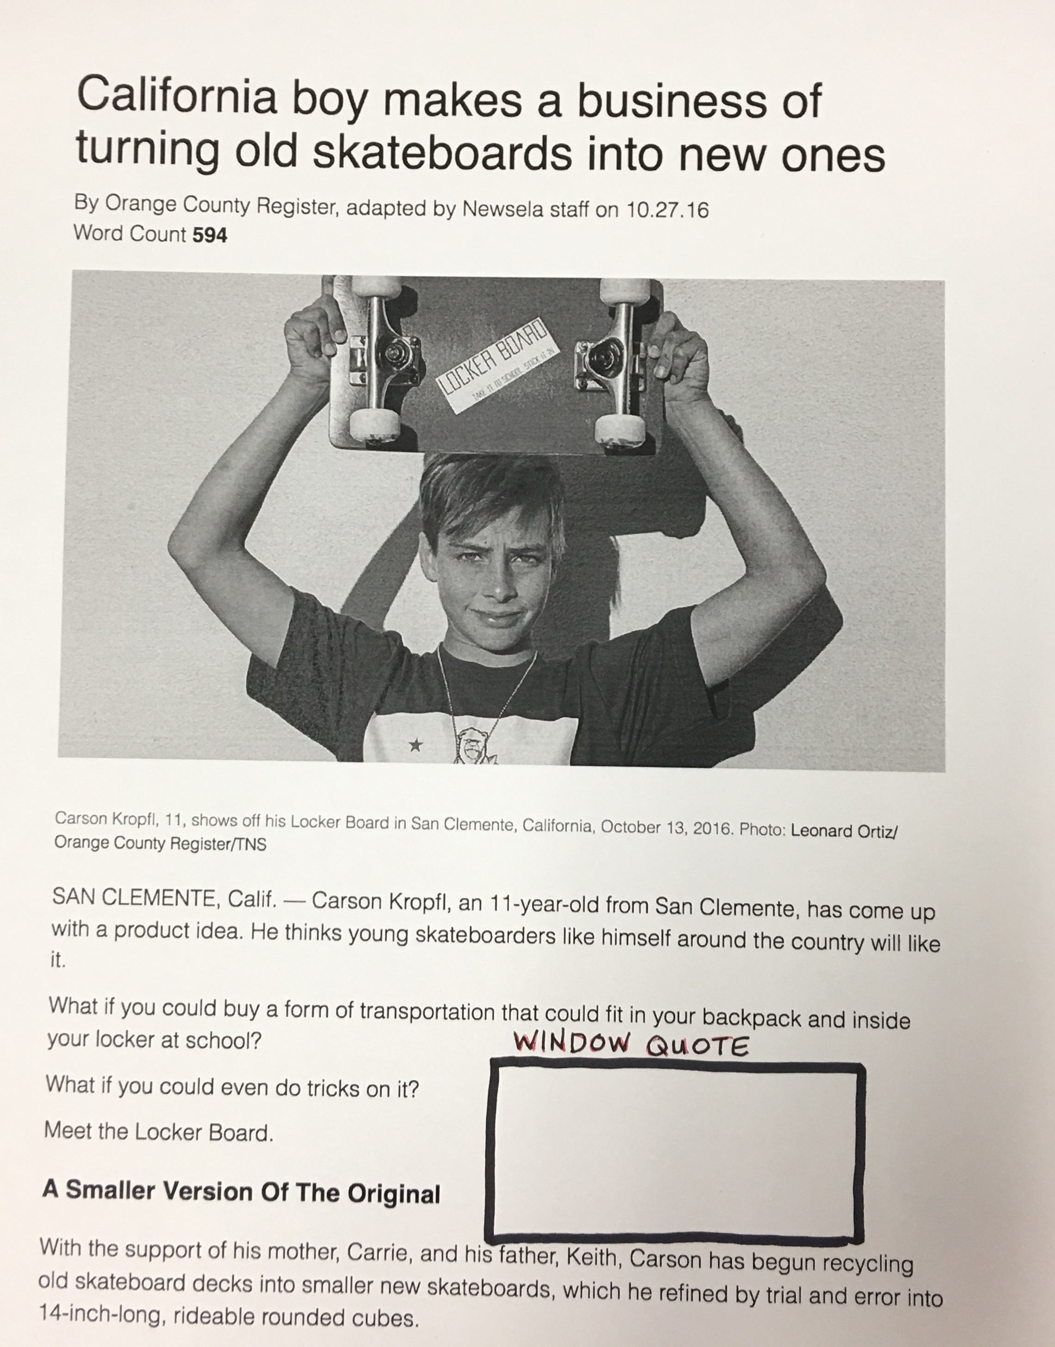
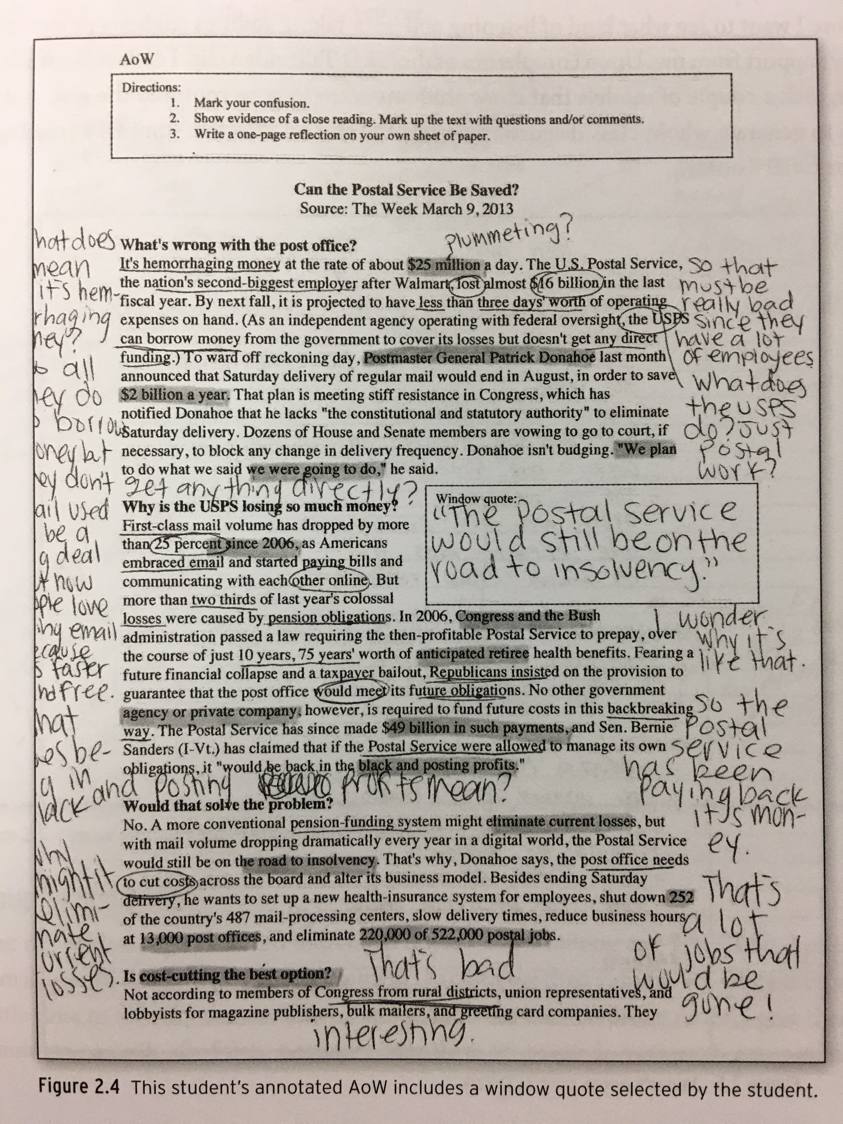

Gallagher, Kelly. In the Best Interest of Students: Staying True to What Works in the ELA Classroom.
Portland, Maine: Stenhouse Publishers, 2015. Print.

