QUIZ, QUIZ, TRADE PROTOCOL

How to Use
1. Create Questions
Provide each student with flash cards (note card or strip of paper) about the current unit of study. One side of the card has a question or vocabulary term and the other side provides the answer or definition. Students can create the cards, too.
2. Pair Up, QUIZ and TRADE
Use the stand up/hands up/pair up method for students to find a partner. Partner A holds up the flash card to show Partner B the question. Partner B answers. Partner A praises if correct or coaches if incorrect. They switch roles and Partner B asks Partner A the next question.
3. Hands Up
After thanking each other and TRADING cards, Partners A and B raise their hands to find a new partner and repeat the process for an allotted amount of time. (Can be done in 5-10 minutes.)

When to Use
Use Quiz, Quiz, Trade at any point in the lesson to structure meaningful conversation.
- Before introducing new material to tap into prior knowledge
- After a unit to review terms/vocabulary or before the final
- At the beginning of the school year as a way for students to get to know each other
- After a math unit to review terms or problems.
- Provide statements. Have students discuss the level in which they agree or disagree. This would be a great anticipatory activity prior to a unit or a reading. There doesn’t have to be a correct answer.
- Before students begin an assignment, such as an essay, a set of word problems or a science activity/experiment, to gather ideas or formalize procedures
- To remediate weak skills
- To practice newly learned skills

Variations
Student-Created Quiz, Quiz, Trade
Have students create their own flashcards with questions and answers. You might want to review the cards before allowing students to play so you can be sure that the students’ answers are accurate.
QQT/IOC (Quiz, Quiz, Trade-Inside Outside Circles or Fold the Line)
To add structure to the process of finding a partner, divide the class into two equal groups. Have one group make a circle and face out. Have the other group make a circle around the first group and face in. Each person in both circles should line up and stand face to face with the person across from them. This person is their partner for the first round of Quiz, Quiz, Trade. Partners ask and answer questions according to QQT procedure. The teacher then gives a signal and the inside circle moves one step to the right and the outside circle moves one step to the left. The person they are now facing is their new partner. Continue for several rounds.
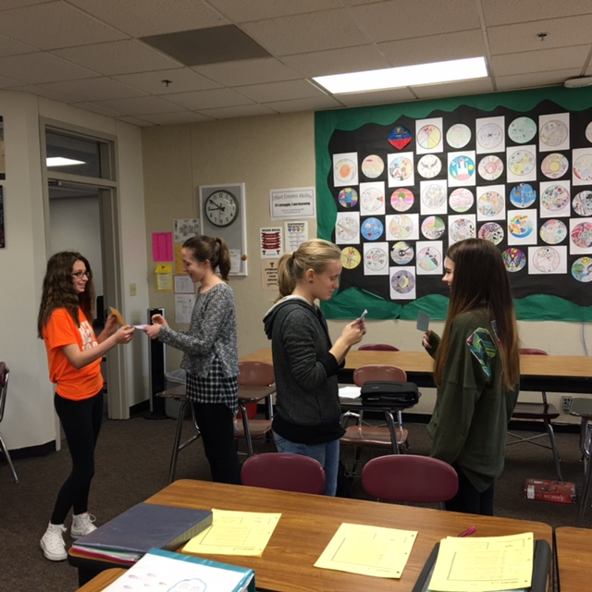  Notice the TRADE happening here. | 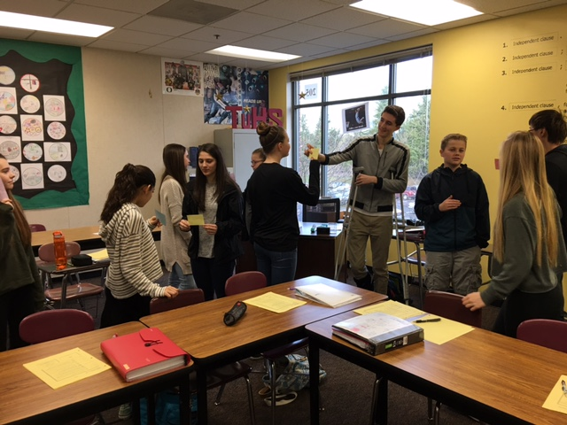This activity is engaging and effective.

Videos
High School example. https://www.youtube.com/watch?v=Q1GGBNBe0oc

Elementary introduction from Teacher Toolkit: http://www.theteachertoolkit.com/index.php/tool/quiz-quiz-trade

