Literary Dominoes

Remember lining up dominoes as a child and watching how the first knocked down the second, the second the third – starting a chain reaction that wound its way through the dominoes until none were left standing?

In a way, the plots of novels, plays, stories, historical events, and science experiments are like dominoes. A happens, which causes B to happen, which in turn causes C to happen – a process that continues until the reader reaches the resolution or the science experiment concludes.

Kelly Gallagher illustrates this point to his students by reading the Dr. Seusss Cat in the Hat classic, Because a Bug Went Ka-Choo! In this story, an incredible chain of events begins when a bug sneezes, causing a seed to fall out of a tree. The seed hits a worm on the head, who in his anger then kicks a tree. The tree drops a coconut and bops a turtle on the head. The turtle falls in the lake and splashes a hen…you probably have the picture by now. The chain of events culminates with an entire city in an uproar.

It’s interesting to have students consider challenging literature from a domino point of view. When Mr. Gallagher introduces this concept, he starts from the last domino and begins working backward (see illustration for what the last three dominoes of Romeo and Juliet might look like).

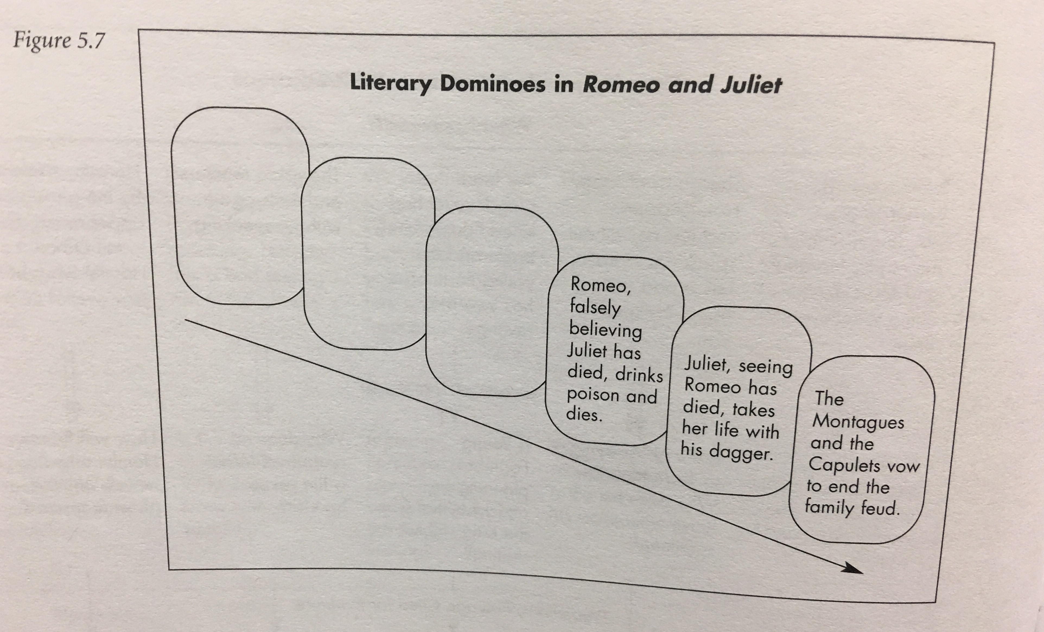
After providing students with the last three dominoes in the chain, he asks them to back up and consider what the dominoes might look like throughout that led to the ending of the play. The students are asked to identify all the key events in the chain that led to the deaths of the two lovers. This strategy could easily be modified to represent the causes leading up to a significant event in history or explain the steps used in a science experiment.

This domino activity is an excellent way to answer the question,
“What does it say?” It prompts students to review the plot points of any major work and requires students to:
- Comprehend (understand the plot, causes or steps)
- Analyze (properly order and connect events)
- Synthesize (modify by answering “What if…?”)
- Evaluate (rank importance of plot points)

To move their thinking to a “What does it mean?” level, he has students write their “dominoes” in order on index cards. A number of questions that require below-the-surface thinking can then be asked:
  - If you were to line up your dominoes of plot/historical events, would they be in a straight line, or would there be curves and offshoots? What does your domino trail look like? How sophisticated is the plot structure?

  - Of all the dominoes leading to the tragedy/historical event/scientific result, which single domino do you think was the key? Which domino carried the most weight in leading to the tragedy/event/result? Explain your answer and cite text references to support your response.

  - Flip to domino number ____ (choose any random number). If you were to remove this domino from the chain – if this specific event/step did not happen – how would the outcome of the play/novel/historical event/experiment have been different? Explain your answer and cite text references to support your response.



