Objective: Show critical attributes of a text or concept, using metaphorical or unusual comparison. This process encourages deep analysis of the subject and moves the students to higher-level thinking.
(Subject) ____________ is like ______________ because_______________.

Teachers can create the categories: animals, food, color, musical instrument, weather pattern, etc. (unlimited possibilities). You can also leave it totally open for them to come up with.
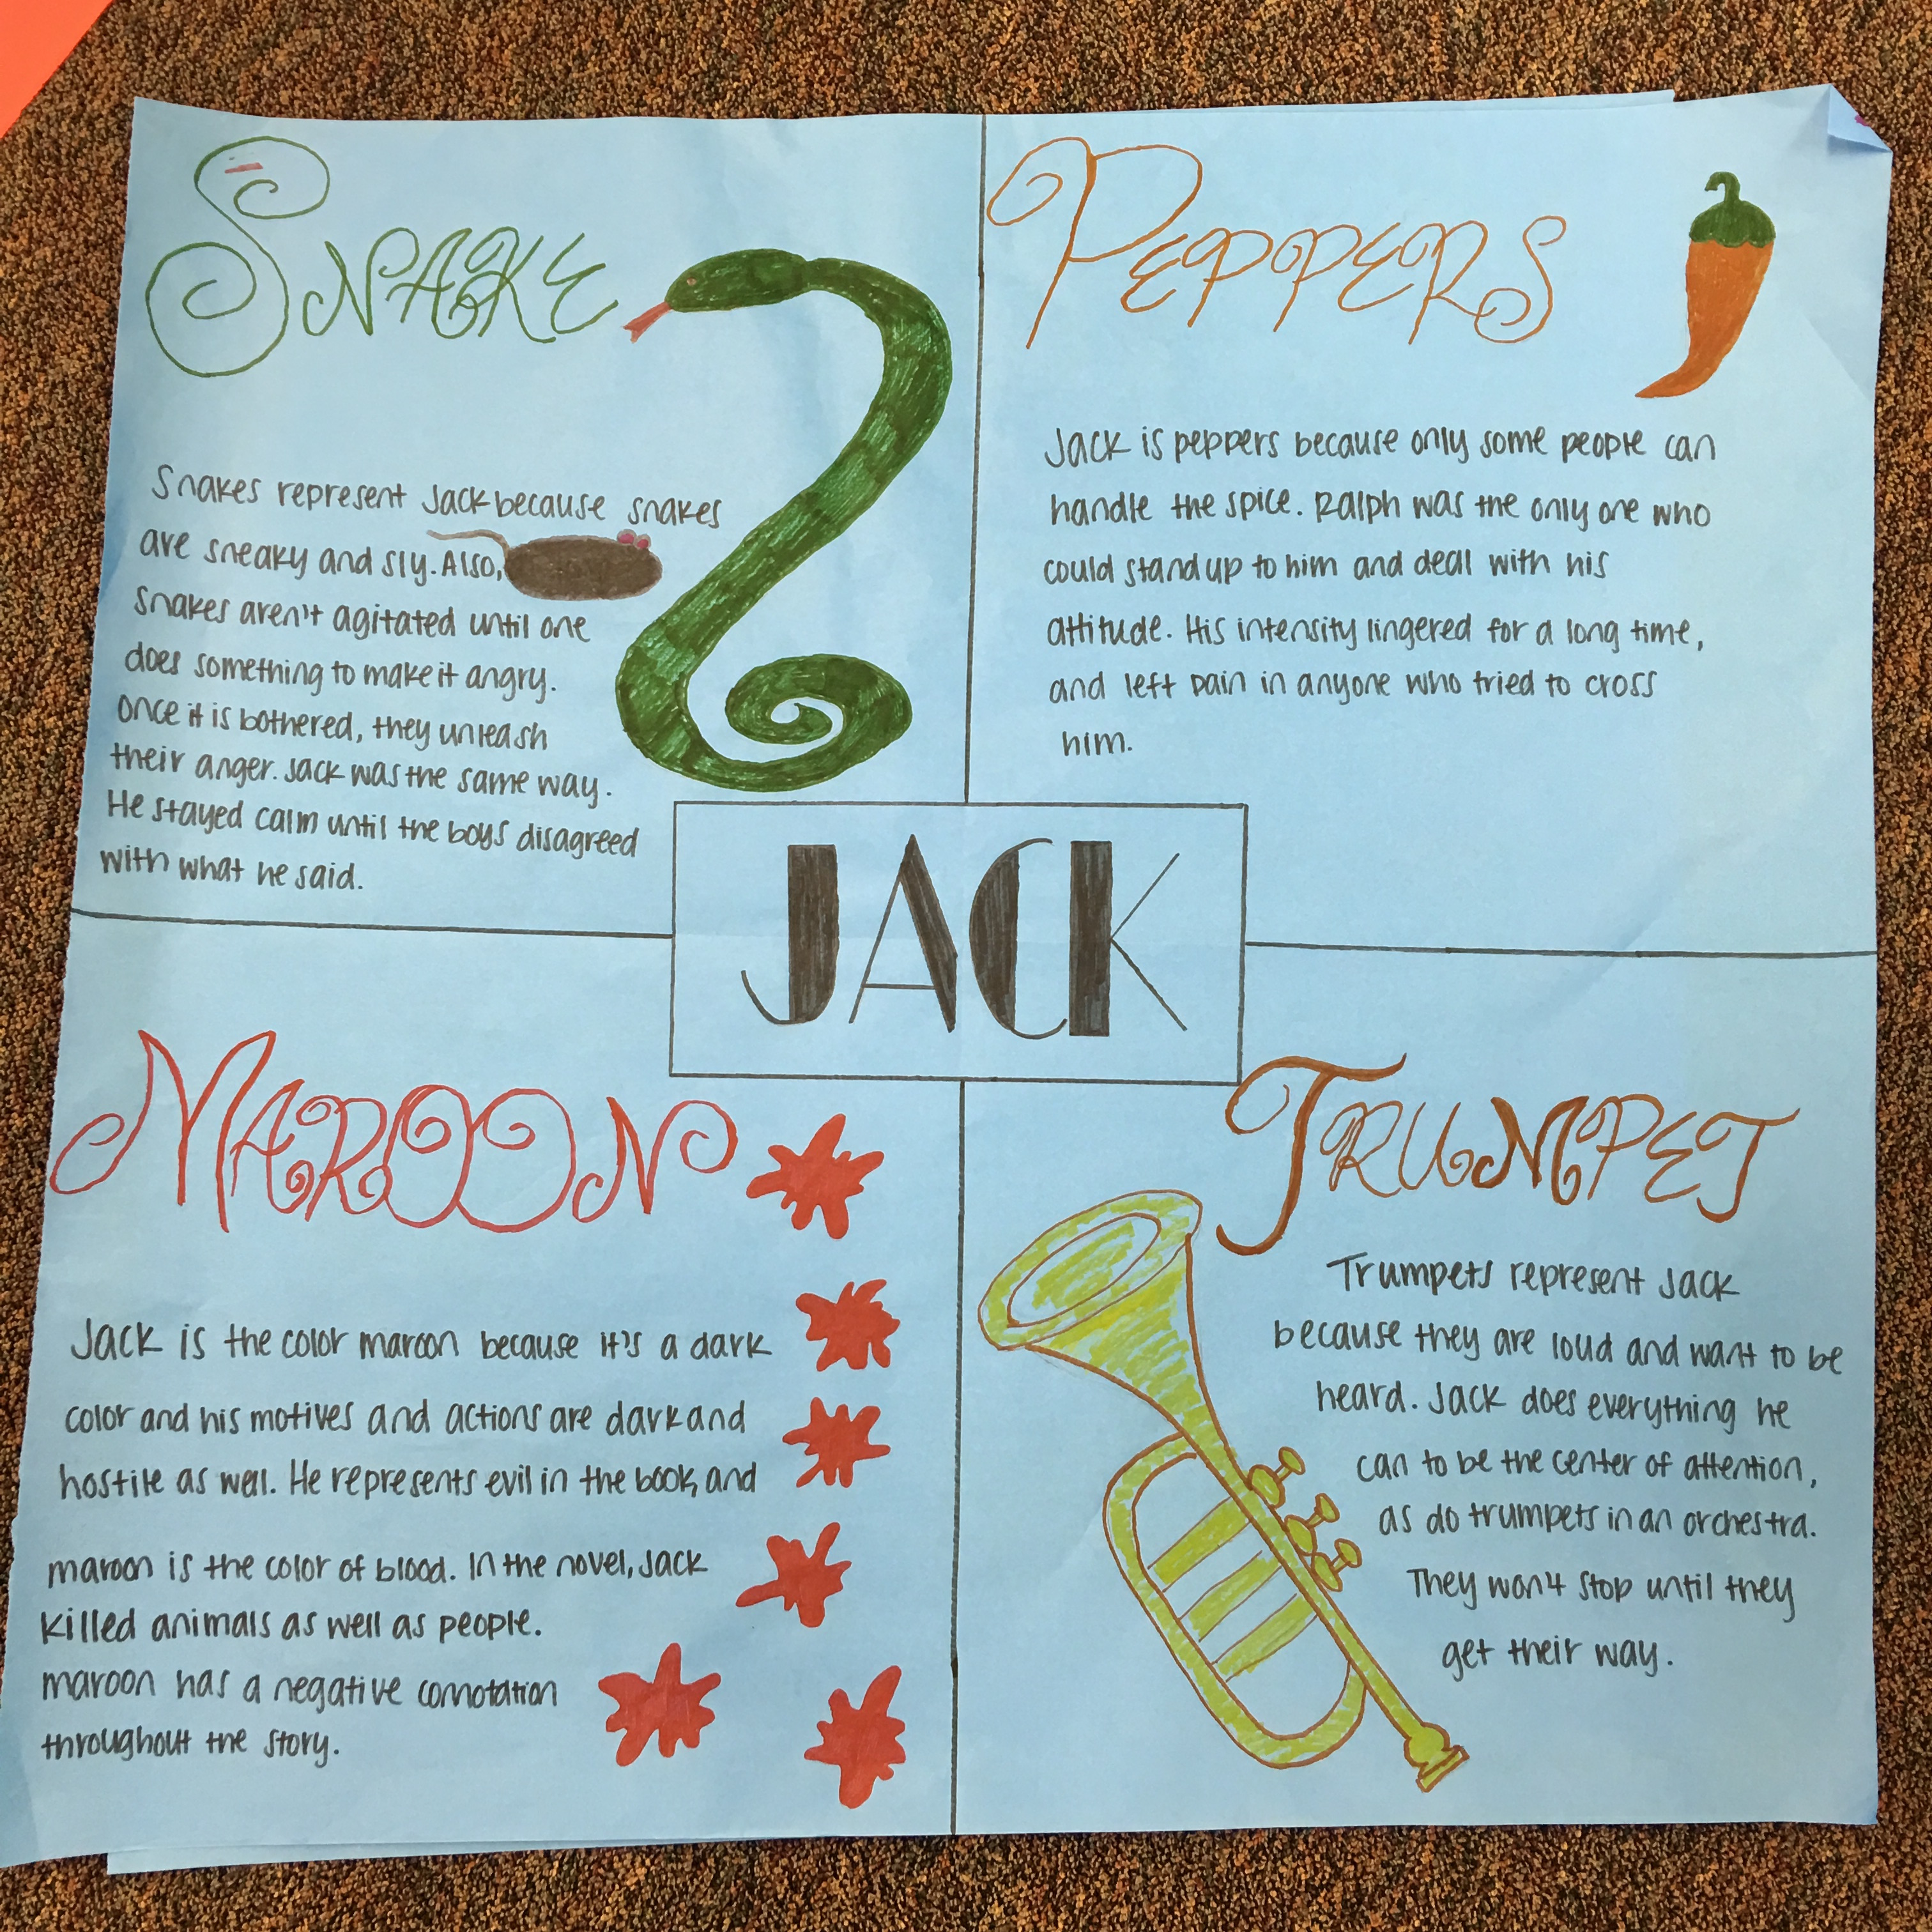
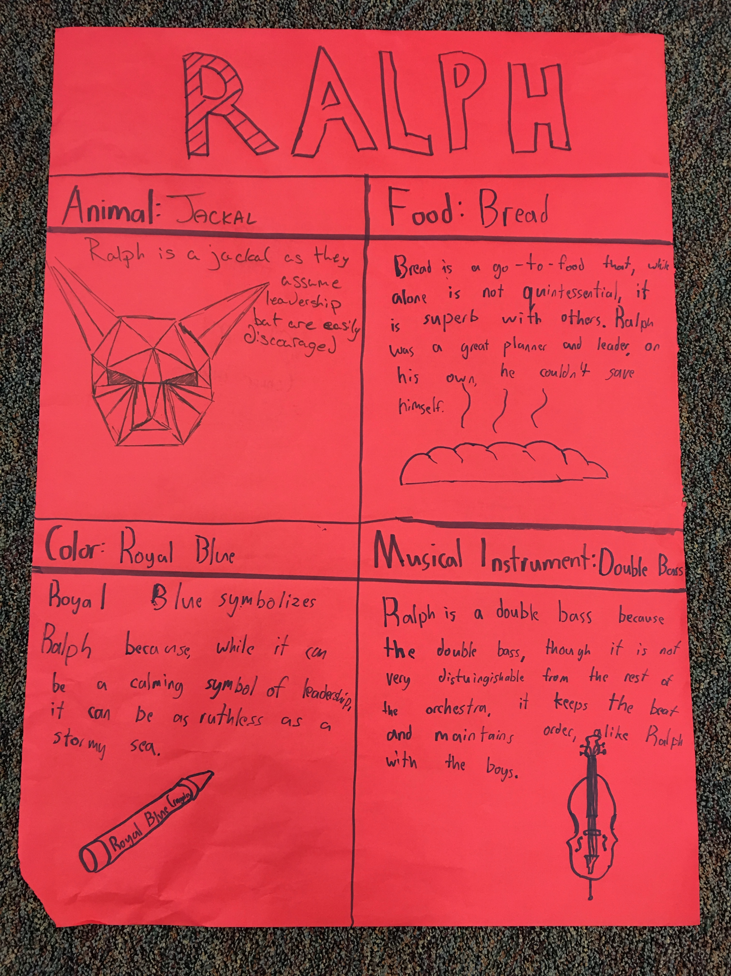
Direct Analogies: How is one thing like another? How is rain like a clock? What animal is like [story character]? What metaphor best describes the process of DNA replication? What does fear look like?
Personal Analogies: What would it be like to be the thing? How would it feel to be an electron? What would life be like as an equilateral triangle?
Compressed Conflicts: How can two opposites come together? Can we have trapped freedom? What does weak power look like?
Science Sample Lesson: Metaphor in Science (Starko, 2010)
Students studying elements, compounds, and mixtures can be challenged to create superheroes based on particular elements—or perhaps compounds or mixtures. Each superhero must be based on the nature of the element chosen, with powers reflective of the element’s characteristics. Students can be challenge to persuade others that their element is the most super of the group. (Adapted from a lesson by Chelsee Harris)

