SIMPLE AUDIO

The extension records your voice and saves the recordings as an audio file
- The name of the extension describes its functionality quite precisely.
- It's dead simple yet powerful and useful.
- Click on the mic icon that lives beside the address bar. After that recording of your voice will begin and you will see a small timer that informs you about elapsed time.
- Click it one more time - the recording will stop and there will be a prompt that suggests you to save your recordings as an audio file.
- Important note. Please don't miss a small popup that you will see after successful installation. The popup will ask you to allow this extension to use your microphone. Click "Allow" and then click the "Turn on" button on the Welcome page.

How to install SIMPLE AUDIO RECORDER:
Step 1: In Google search bar, type in Chrome Web Store
Step 2: In web store, type in Simple Audio Recorder
Step 3: Hit the blue +ADD TO CHROME button
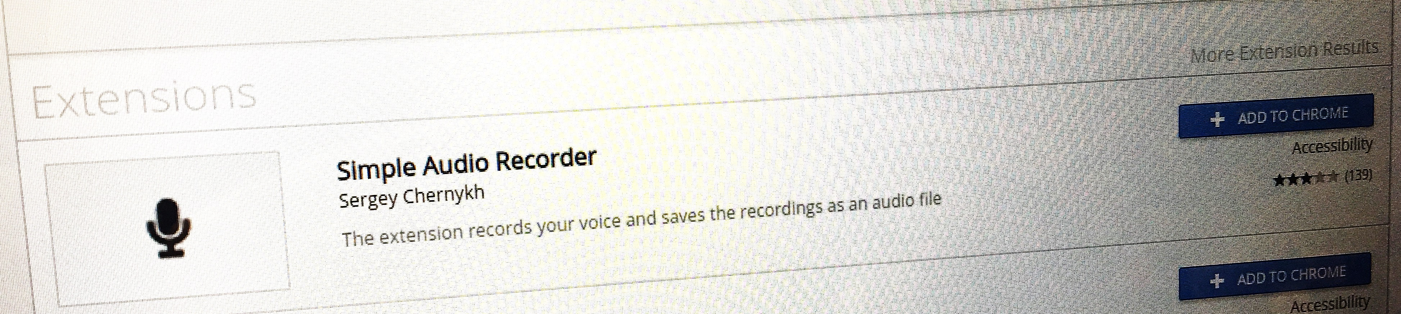

Step 4: When a popup window appears, hit ALLOW for “use your microphone.”
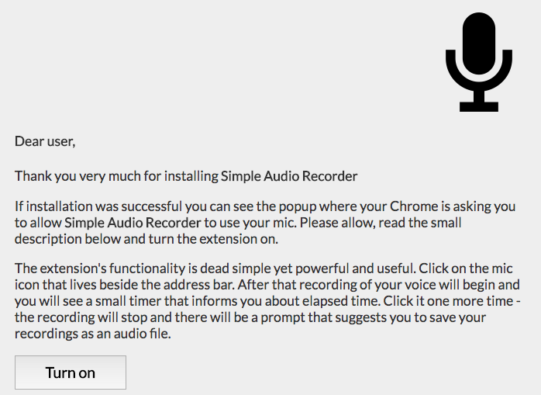
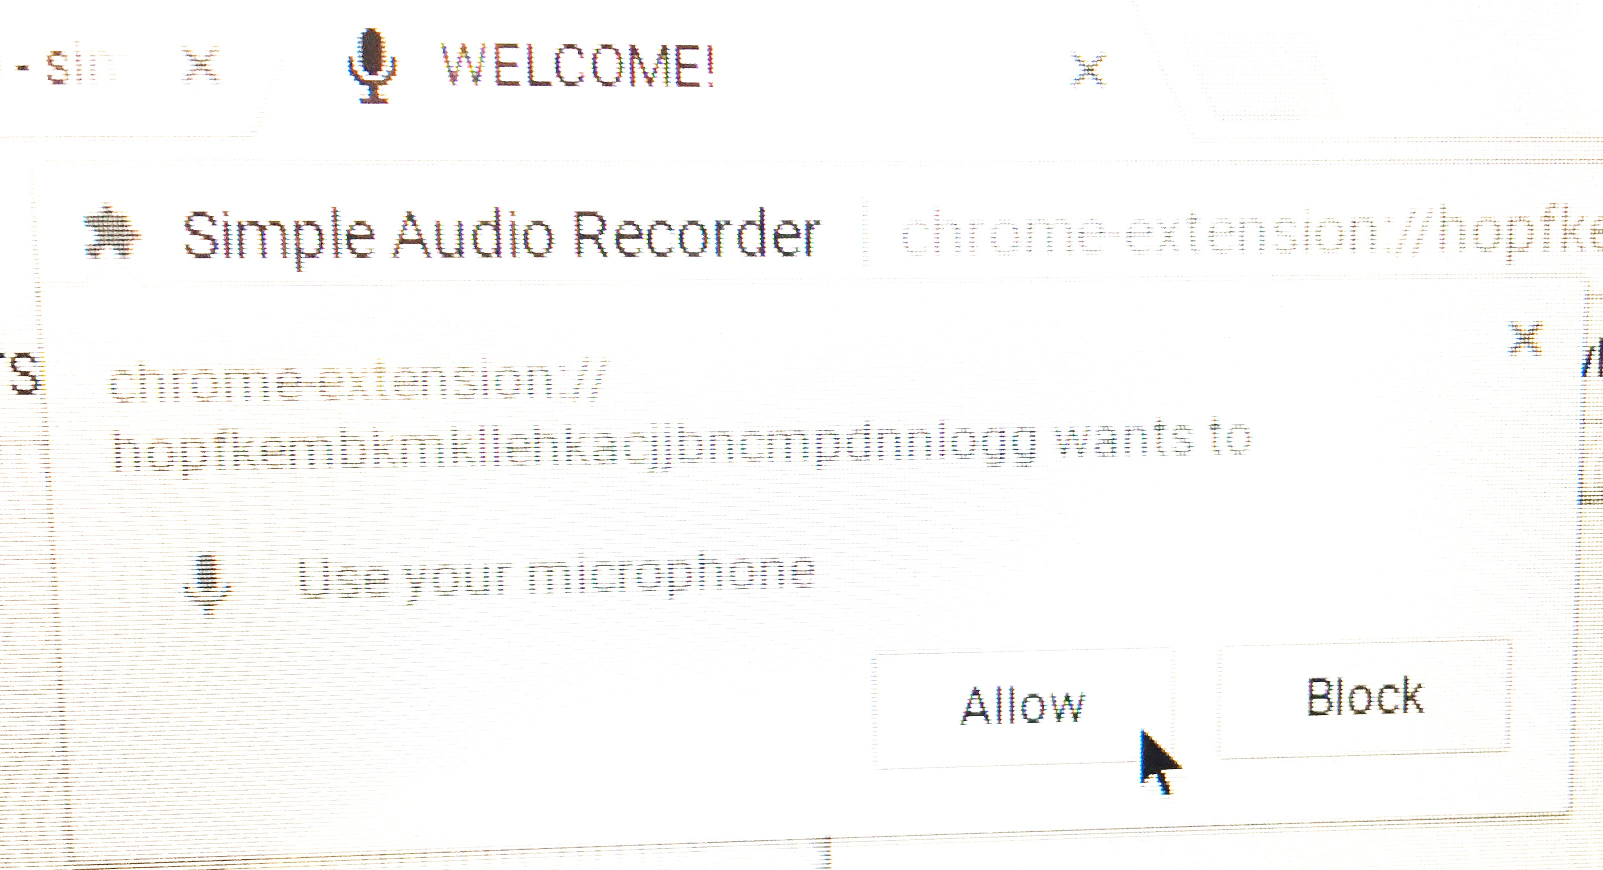

Step 5: Press the little mic icon in your tool bar to start recording.

Press the icon again to stop recording. It will save the audio file right into your Google Drive.

SO EASY!

Troubleshooting:
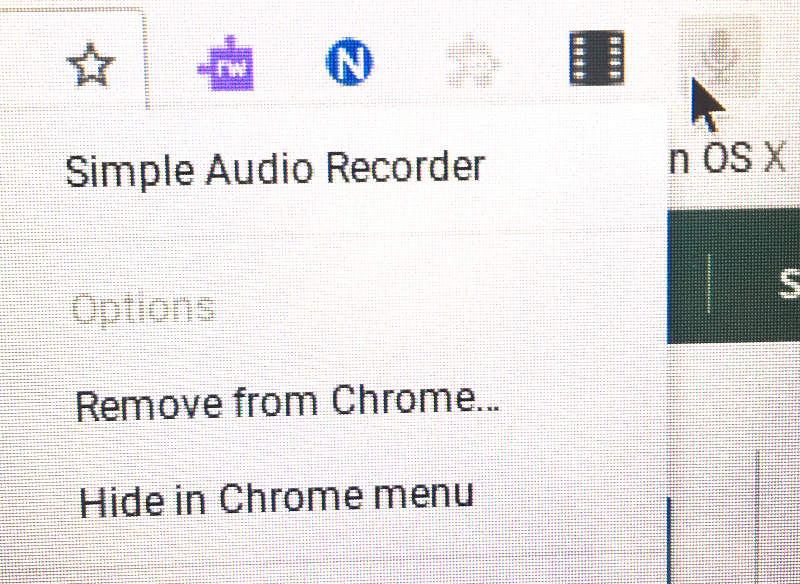
If the mic icon is grayed out, the student did not allow the microphone.

Simply, uninstall the app by clicking on the mic and then select “remove from Chrome”

Now, go through the steps again to reinstall and be sure to allow microphone.
S

STUDENT TESTAMONIALS:
Was this process an effective revision and editing tool? Please explain.

“It was a good way to catch things I can’t notice when I’m reading it in my head. It kind of reminds me of the little phones made out of pipes that we had in elementary school, where you could whisper into it and hear yourself read. Also, I can tell my brother that his editing skills are rusty because he missed some mistakes.”

“YES!! It was absolutely worth the time reading and listening to the recording! Reading aloud makes it clear whether the sentences make sense, or if they are too long, if there are awkward transitions, or errors in tense.”

“EXTREMELY useful, it allowed me to see a bunch of mistakes that I didn’t see before. There are literally “Oh” moments in my recording from the mistakes that I made.”

“This was effective because I noticed more errors than when we did partner edits and when I just read the paper in my head. We write how we want to read, but in many cases, as novice writers, it gets messy, so reading it aloud can help us realize this.”

What do you notice MOST about your writing?

“I noticed that my writing had some pretty long and complicated sentence structures. Sometimes, sentences or ideas were a bit skippy and jumped ahead making assumptions that the reader didn’t know.”

“There are a few unnecessary details that don’t add to the writing. There were also a couple of grammatical mistakes that I noticed while reading it aloud.”

